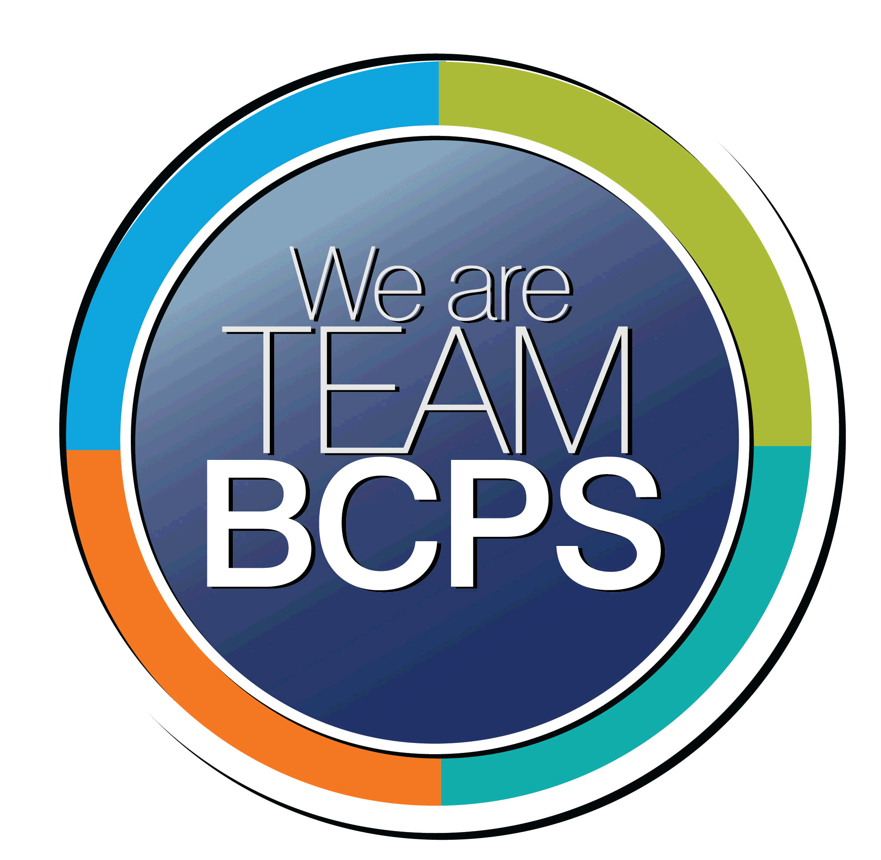 Schoolwide Positive Behavior Plan 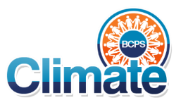
Baltimore County Public Schools

Date Completed: Summer 2023 School Year 2023-2024
School: Hebbville Elementary School

Section 1: Initial Steps
School Climate Team
Identify members of a School Climate Team (consider a representative selection of members). The team meets initially to examine equity concerns and data and to develop the Schoolwide Positive Behavior Plan. The team should then meet monthly (minimum quarterly) to assess the effectiveness of the SWPBP on an ongoing basis.
The school will identify a School Climate Team to review the Positive Behavior Plan, implement the interventions suggested by the SWPBP, and monitor its effectiveness. There is a designated administrator who will work with the team which is composed of teachers and other school staff which represent the diversity of the school building. The School Climate Team will meet monthly.

The members of the school climate team consist of representatives of various stakeholders within the community. The plan was initially outlined by the following members and revised and supported by the entirety of the team:
Amanda Fischer, Teacher
Brianna Puryear, Teacher

Other Members:
Jordan Filderman, Principal
Katelyn Shenton, Assistant Principal

The school has identified a School Climate Team which is composed of an administrator, grade level teachers, a special educator, a special area teacher, and a member of the student support services staff [e.g., school counselor, school social worker, school psychologist, and/or PPW]. The teachers represent the diversity of our school. The team will meet monthly to discuss implementation of interventions, monitor the effectiveness of the interventions, and suggest changes or modifications to those interventions.

Equity Lens
Through an equity lens, identify what the data indicate about the social-emotional needs of students and the support provided by staff members relative to disproportionality between student groups, especially for African Americans or students receiving special education. Also consider the school’s population with regard to ELL, Latinx, and/or other student groups. (Information may be from School Data Story)
The team will create the space for educators to examine and interrogate their personal biases to become aware of the ways in which their own cultural experiences influence the conditions and learning opportunities that they create for students, with a strong emphasis on how their language may impact student perceptions on appropriate actions in the classroom. Administration will provide frequent and actionable informal feedback to support professional growth towards a more inclusive and equitable school environment. To do this, the team will consider both the cultural vision of our school and the current curriculum of Conscious Discipline and Restorative Practices.

Hebbville Elementary School will create a culture of educational excellence by becoming a community of learners who believe in and support the realization of the promise of all students.
- Teachers will demonstrate commitment to a culture of educational excellence by engaging in the implementation of conscious discipline and restorative practices which empower student voice, support student engagement free of bias, and avoid power struggle.
- The Administration and resource team will partner with C&I staff to provide continued professional development for Conscious Discipline and Restorative Practices.
- The teachers will engage in training and the implementation of Second Step to supplement our PBIS goals.

Second Step is a program for kindergarten through fifth grade is a universal, classroom-based curriculum designed to increase students' school success and decrease problem behaviors by promoting social-emotional competence and self-regulation. It teaches skills that strengthen students' ability to learn, have empathy, manage emotions, and solve problems. The program targets key risk and protective factors linked to a range of problem behaviors. Equipping students with Second Step skills creates a safer, more respectful learning environment that promotes school success for all.

Conscious Discipline is an evidence-based, trauma-informed approach. The Harvard study’s authors say, “Conscious Discipline provides an array of behavior management strategies and classroom structures that teachers can use to turn everyday situations into learning opportunities.” Conscious Discipline encompasses these four components, which are scientifically and practically designed for success:

Restorative Practices do more than supplant punitive approaches to discipline. They can dramatically improve the school climate and strengthen the social and emotional skills of young people and adults. Instead of using punishments and rewards to influence the way students behave, restorative approaches address the underlying reasons for students’ hurtful behavior and nurture their intrinsic desire to treat others with care and respect.

Conscious Discipline and Restorative practices work together to create a positive school climate. While Conscious Discipline guides everyday classroom culture, Restorative Practices provide a structure of protocols when situations in the classroom go awry. Second Step teaches the students the skills they need to develop positive relationships and foster self-regulation.

Data Analysis
Summarize what the data tells about the school climate. (Information from School Data Story)
As represented in 2022, when looking at the data, the team gleaned that there is a distinct split between the representation of our home-school student within a comprehensive classroom and the regional SEL students. When looking at our regional students, we determined that the needs, and therefore supports for these students were different and we needed to split the data in order to better understand the students in our school. To better understand our students, we will break this data into two subgroups.

For the home-school/inclusion students, we noticed that only 24% of the office referrals were in response to students within the general education setting. In addition, 26% (19/71) of those student referrals came from one student, and 40% (29/41) came from another student. Both students are being supported through the IEP/SST plan process. In addition, only 7% of the office referrals were from general education students besides these two whereas
76% of the office referrals came from the regional SEL program, which consisted of 12 students. Most of these referrals were written as a result of the antecedent of “presented with work” or “presented with non-preferred activity”. Student individual data, as well as SEL teacher data support an overall decrease in the frequency of these behaviors, with a sudden increase upon the return of students to the physical school building.

The team discussed this data and found that the referral data was not statistically significant enough to warrant a goal, as most students were not being addressed through this process.

The team also discussed that this data did not allow for in-class interventions to be recorded, quantified or evaluated. The team determined that we would need more ‘teacher collected’ data to drive the implementation of interventions.

We have determined that this data is still relevant and Second Step will be used as an Tier 1 behavior intervention to be taught to all students.

Climate Goals
Identify the school’s goals in improving the social-emotional climate of the building. (Information from School Progress Plan)
The current SPP goal is related to attendance and student’s sense of belonging. The goals are written as followed:

- Decrease the percentage of students chronically absent from 32.2% in 2023 to 15% in 2024.

The team discussed the current goals and determined that the following goal would benefit our school community as a whole:

- As measured by the Stakeholder Survey, students’ sense of belonging aggregate score will increase from a baseline of 58.5% in 2023 to 70% in 2024.

The team reviewed and acknowledged various studies that point to a correlation between a strong positive behavior support system and student sense of belonging. The studies concluded that a strong PBIS system decreased non-desired behaviors and resulted in more positive interactions between staff and students, increased time on task and increased standardized test scores. In addition, studies have shown that increased positive interactions will also increase attendance. The quality of a school social environment has a profound impact on a student’s overall sense of well-being.

To address these climate goals of our SPP, the team determined that our objective within the SPP goal will be:

- Teachers will implement Second Step with fidelity in order to create a positive climate and community. The team will deliver professional development and support teachers in delivering instruction and supporting students as they develop positive behaviors. By increasing attendance rates and implementing a culture of respect, Hebbville will decrease undesired behaviors and increase time on instruction.
- Teachers will strategically plan and develop systems to address student behaviors. The team will create an RTI process to support staff and other stakeholders in providing concrete guidance in developing and implementation of classroom behavioral systems. We will then refine and support using the RTI methods. Providing support through coaching, data collection and interpretation and plan creation/implementation for students at risk of interfering behaviors that impact their learning.

This goal is to create a culture of learning where on-task behaviors are supported and encouraged, rather than punitive efforts for off-task behaviors. This will allow teachers to respond to misbehaviors effectively and reduce time spent on redirection resulting in increased instructional time. To support this the team will provide the following:

- Implement Second Step at a school wide level.
- Develop individual positive behavior plans
- Increased use of the Student Support Team process
- Provide additional professional development opportunities
- Strategic tracking of student behavior referrals to the Focus Room
- Increased effective use of FOCUS for both minor and major teacher behavior referrals

The Hebbville Lesson Planning documents require teachers to consider equity as a part of their pre-planning process. This is often a topic of discussion during pre-observation conferences and is designed to force reflective practice prior to planning instruction.

Section 2: Developing and Teaching Expectations
Expectations Defined
Identify a School Code of Conduct with 3-5 positively stated school expectations. Develop a way to communicate the identified rules, based on the schoolwide expectations, for specific settings within the school building. Expectations should be clearly stated, communicated, taught, and frequently referenced.
As a proud member of the Hebbville Elementary School Community…
Here at Hebbville, we:
- Respect Ourselves
- Respect Others
- Respect Our School

Classroom Plan for Teaching and Reinforcing Expectations, Routines, and Procedures
Teachers develop visuals to communicate culturally relevant classroom expectations, routines, and procedures based upon the schoolwide expectations. Educators explicitly teach expectations, routines, and procedures. The school staff recognize and reinforce expected and positive behavior. Teachers identify encouraging procedures and corrective procedures for their classrooms.
- Use morning meetings, check-ins, and check-outs to build community: Second Step lessons, Conscious Discipline, lunch bunches...
- Celebrate all students, catch them doing something good by utilizing office tickets
- Make positive connections with students
- Involve parents/guardians and build trust – Be professional, honest, objective, and helpful:
Make phone calls to share positive information: All families should have received communication from teacher within first month of school through phone call
- Allow students to visit a buddy teacher for a short break and reflection if necessary:
Have a separate desk for visitors from a buddy classroom
Greet buddy student and without interrupting instruction remind them of where to sit. Activity sheets should be at this desk and team leaders should facilitate with the team what is expected of the student to be doing with the teachers of that grade level.
- Provide logical consequences for students: Use progressive discipline flow cycle to guide consequences.
- Recognize each new day as a fresh start: Greet students who need restorative practices, returning from Focus room and consequences with a positive affirmation and connection with the teacher.
- Implement class wide behavior incentives (e.g., small marble jar): This should be tied into the school wide RESPECT initiative and preferably the grade level should be attempting to create similar incentives within their grade level to create consistency.
- Coordinate recess with team members to supervise disciplined students and those that are playing.
- Putting students out in the hallway without supervision is not acceptable at any time. If you need assistance with a student, please follow appropriate protocols. Students should always have a pass when leaving the room. IE: finding Wi-Fi pass, premade passes for pull out groups...

Family/Community Engagement
Identify how the Schoolwide Positive Behavior Plan, the schoolwide expectations, and/or interventions will be communicated and shared with families. Consider how to include family and student voice in the initial plan and in evaluating the plan throughout the year.
Due to the subjective nature of classroom management, the team considered the differences in each teacher’s ability to follow a singular behavior plan. After much consideration, the team determined that individual teachers and groups would benefit most from having the opportunity to create and implement a plan that suits their teaching style and expectations, while still maintaining the rigor and high standards of the school-wide expectations. As the staff at Hebbville has grown and is creating a culture of consistency, a school-wide concept of expectations is expected to be followed by students as staff. As much as possible grade levels should create a similar behavior plan so that students can change teachers and move within the building to other classrooms and still understand expectations.

The team determined that the ‘jump off’ point for the community engagement piece could be "Back to School Night”, so that teachers and teams can introduce families to their plan and methodology. To support teachers and teams, the administration will be providing a database of resources for staff to pull tools and ideas from within our Hebbville Staff Schoology Course. We will revisit these concepts with families during intermissions of community events and during conference nights.

The BCPS Student Behavior Handbook is reviewed with each class and student in the beginning of the year. This handbook is also sent home to student families, in which they are asked to discuss school expectations and sign a receipt stating that they have received this document.

In addition, the team will be introducing the school-wide expectations to families and members of the community during ”Back to School Night”.

Section 3: Developing Interventions and Supporting Students
Resource Mapping of MTSS
Identify the evidence-based practices and interventions offered at Tier 1, Tier 2, and Tier 3 to support all students. Consider what culturally responsive interventions the school requires to meet the specific needs of the students.
- The team will use the RTI model created for the tiered supports of the MTSS model.
- Individual and class wide Positive Behavior Supports will be implemented in each classroom.
- The Hebbville Behavior Team will meet regularly to discuss students who are standing out as needing more intensive behavior support to develop a plan and provide the support needed.
- The SST process with be implemented for student’s needs behavioral interventions and supports put into place. Interventions will be documented and RTI data will be gathered.
- Focus room interventions are available for students needing behaviors interventions when dysregulated and not able to participate in the whole class setting. This is a temporary as needed intervention used to help the student regulate and process emotions in the moment.
- School Social Worker and School Counselor will pull individual and small groups to work on social skill, behavior interventions, and restorative practices.

Social-Emotional Learning
Identify the specific evidence-based social-emotional learning skill development practices the school will implement during the school year. Consider the importance of trauma-informed care, mental health awareness, level of students’ coping skills, etc. Determine how the social-emotional learning and the SEL competencies will be integrated into the school’s programming. Consider the need for any training the staff members may require.
- The Behavior Team will implement Restorative Practices and Conscious Discipline.
- Second Step will be taught in each classroom with fidelity during morning meetings, with Conscious Discipline as a secondary tool.
- All classrooms will have a safe space/calming corner available for student use as needed.
- Hebbville Elementary has an SEL lending library of materials for SEL lesson implementation.
- Each month, Hebbville will focus on an area of mental, physical and community well-being through the Second Step curriculum, through use of daily announcements and school or grade wide level assemblies.

Character Education
Determine how specific evidence-based character education learning will be infused into the school’s programming to promote positive behavior and ethical decision-making. Character education will be culturally responsive and co-created with diverse stakeholders. Consider the need for any training the staff members may require.
The team will use the evidence-based character education lessons and curriculum within conscious discipline to create a culturally responsive classroom where social/emotional learning occurs frequently. Each month, Hebbville will focus on an area of mental, physical and community well-being through the Second Step curriculum, through use of daily announcements and school or grade wide level assemblies.

Professional Development for Staff
Identify the professional development that will be offered to staff members throughout the year in order to support their knowledge, skill development, and implementation of the interventions selected, the character education learning, and social-emotional learning practices. Specify the schedule for professional development and how to obtain teacher feedback during the year to address their concerns and areas in which they want/need more information. (Information from School Progress Plan.)
The staff will be provided with training on the RTI model to proactively address behaviors that may impact student achievement (i.e., absenteeism, off-task behaviors). In addition, staff can attend optional training opportunities on Conscious Discipline and Restorative Practices as needed. Staff will receive Second Step introduction and training at the beginning of the year. The staff will receive the progressive discipline flow chart at the beginning of the year. Classroom teachers will review attendance data twice quarterly at monthly meetings and identify students with absenteeism patterns.

Section 4: Supporting and Responding to Student Behavior
Recognitions/Incentives
Identify a variety of positive consequences, acknowledgements, recognitions, and/or incentives that are linked to the behavioral expectations and rules. Develop a system for implementing positive acknowledgements consistently in school settings. Consider how to monitor who is being recognized and who is not being recognized and whether explicit or implicit biases may be occurring.
- Each teacher will support exciting quarterly events that have been historically successful at Hebbville for decades.
- Tie attendance into reward eligibility. Students with attendance lower than 90% should be considered as possibly ineligible for unexcused absences.
- Quarterly award ceremonies will be held for primary and intermediate grade levels.
- Schoolwide behavior “Gotcha” awards will be handed out by support and administrative staff for positive behaviors. VIP cards could be used to incentivize students with exceptional behavior.
- A cafeteria point system will be implemented for each class to obtain a monthly incentive. The incentive needs to be predetermined and posted next to the points chart. Points should be articulated to teachers daily.
- Schoolwide PBIS expectations will be shared and reinforced on the announcements along with visuals throughout the building. Once quarterly, we will have a PBIS assembly to reinforce these expectations and be tied into awards ceremonies.

Hierarchy for Behavioral Referrals and Consequences
Identify the behaviors that are teacher-managed, behaviors referred to resource staff, and behaviors referred to administration. Refer to the BCPS Student Handbook for teacher and administrator-led interventions. Consider how unsafe behaviors will be addressed.
In the staff handbook, the hierarchy for behavioral referrals can be found. Most behaviors are managed by teachers unless it is chronic or higher in severity.

In essence, behaviors that warrant administrative intervention are as follows:
- Fights or aggression towards peers or staff
- Chronic disruption (defined as at least 3 repeated occurrences of a behavior that slows or stops learning in the classroom)
- Weapons or threats of weapons
- Elopement/Walking out of designated area

In all other cases, administration or designees will provide support to teachers and students in developing a positive classroom culture that is conducive to learning. See progressive discipline flow cycle.

Response for Intensive Behaviors
Identify a hierarchy of responses to intensive behaviors (i.e., emergency/crisis management/threat assessment/unsafe behaviors) including interventions and supports. Indicate which school staff members will respond as well as procedures and training as needed.
In the staff handbook, the hierarchy of RTI can be found. Most behaviors fall into classroom managed behaviors, with the option of ‘buddy teacher time’ for recurring behaviors and crisis intervention with behaviors that are high-magnitude or unsafe. Discussions about chronic behaviors and solutions for students with undesirable behaviors will occur during team meetings.

Monitoring the Schoolwide Positive Behavior Plan/Data Analysis
Identify the data that will be collected and reviewed by the School Climate Team in order to identify behavior trends, patterns, action steps, and interventions using a problem-solving strategy. Consider having a uniform referral form for staff to complete to document referrals to administration. Consider how teachers should document classroom-managed concerns/behaviors/difficulties. (Information from School Progress Plan.)
The team, with the support of the SEL teachers will collect and analyze the behavior data collected quarterly. This data will be used to move forward with small group sessions, additional CD lessons and counseling will be recommended.
- Student minor and major referrals submitted in FOCUS correctly
- Focus room data collected by school Behavior Interventionist
- Student behavior data collected through the RTI process
- SST Student Intervention Plan and 504 Plan data pertaining to behavior
- FBA and BIP data is collected for tier one students needing this intervention in place

Section 5: Miscellaneous Content/Components

